**SQL SELECT SOURCE CODE AND SCREENSHOTS**

**-- Enter a train name and retrieve all the passengers with confirmed status travelling in that train**.

SELECT DISTINCT PassengerName

FROM Ticket t, Train r, Passenger p

WHERE p.PassengerSSN = t.PassengerSSN

AND r.TrainNumber = t.TrainNumber

AND TicketStatus = 'Booked'

AND TrainName = 'Flying Scotsman';

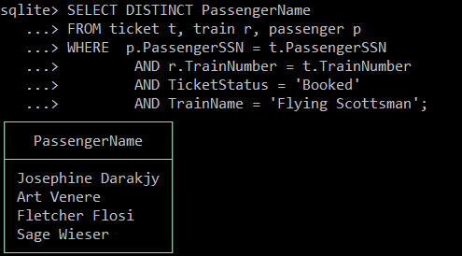

**-- List all the trains where the waiting list is full along with passengers on the waiting list in descending order.**

SELECT DISTINCT TrainName, PassengerName

FROM Ticket t, Train r, Passenger p

WHERE TicketStatus = "WaitList"

AND p.PassengerSSN = t.PassengerSSN

AND r.TrainNumber = t.TrainNumber

ORDER BY PassengerName DESC;

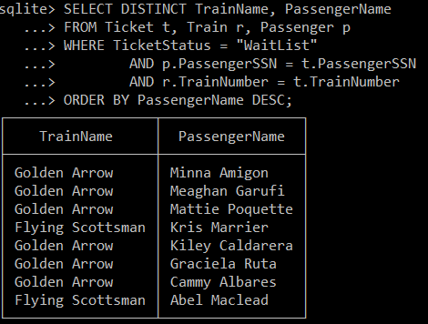

**-- Cancel a ticket (delete a record) and confirm that a passenger on the waiting list gets a ticket status confirmation.**

DELETE FROM Ticket

WHERE PassengerSSN = '123456789';

UPDATE Ticket

SET TicketStatus = 'Booked'

WHERE PassengerSSN = '987654321';

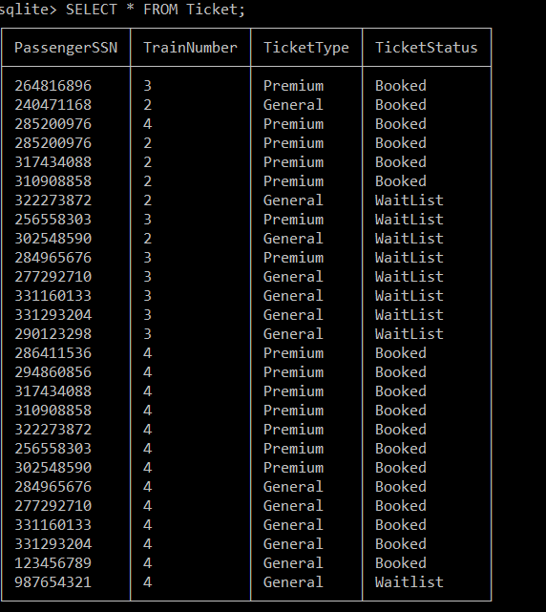

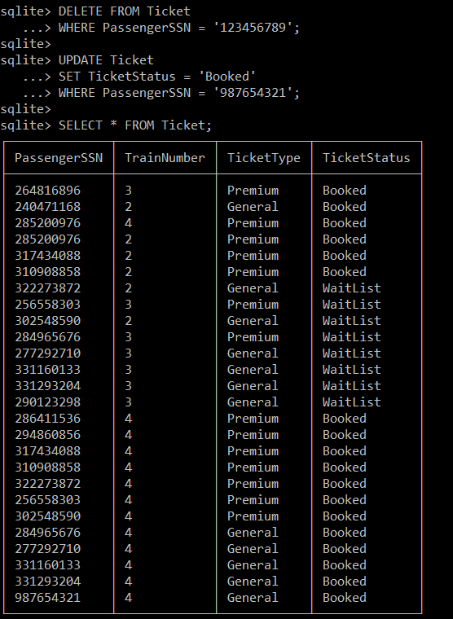

**-- List the passengers travelling on Sunday with confirmed tickets.**

SELECT DISTINCT r.TrainName, PassengerName, TrainDate

FROM ticket t, train r, passenger p, TrainStatus ts

WHERE p.PassengerSSN = t.PassengerSSN

AND r.TrainNumber = t.TrainNumber

AND r.TrainName = ts.TrainName

AND TicketStatus = 'Booked'

AND TrainDate = '2022-02-20';

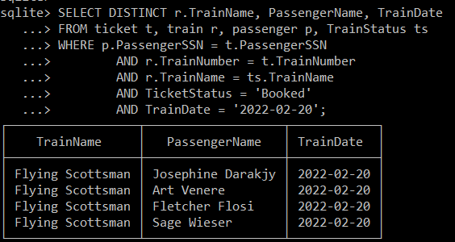

**-- For each train, list the train’s name and the number of occupied and available seats.**

SELECT *

FROM TrainStatus;

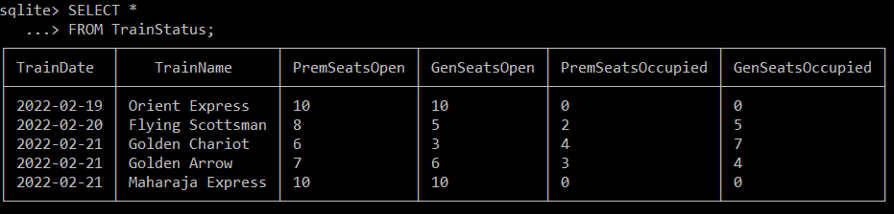

**-- Enter the passenger’s last name and first name and retrieve all trains they are booked on.**

SELECT TrainName

FROM Train r, Passenger p, Ticket t

WHERE p.PassengerSSN = t.PassengerSSN

AND r.TrainNumber = t.TrainNumber

AND PassengerName = 'Abel Maclead'

AND TicketStatus = 'Booked';

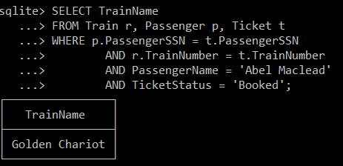

**-- Get the train information (Train Number, Train Name, Source and Destination) and passenger information (Name, Address, Category, ticket status) of passengers who are between the ages of 50 to 60.**

SELECT r.TrainNumber, TrainName, TrainSource, TrainDestination, PassengerName, PassengerAddress, TicketType, TicketStatus

FROM Train r,Passenger p,Ticket t

WHERE p.PassengerSSN = t.PassengerSSN

AND r.TrainNumber = t.TrainNumber

AND PassengerAge >= 50 AND PassengerAge <= 60;

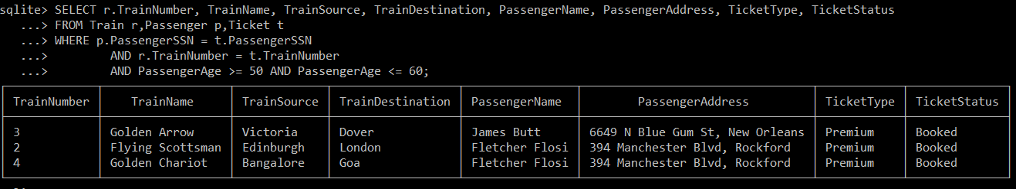

**-- List all the train name along with count of passengers it is carrying.**

SELECT r.TrainName, PremSeatsOccupied + GenSeatsOccupied

FROM Train r, TrainStatus ts

WHERE r.TrainName = ts.TrainName;

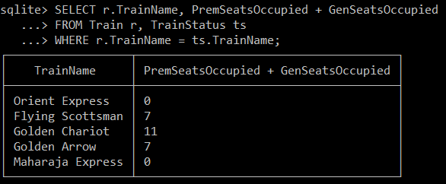

**-- List all passengers who are travelling on Saturday and Sunday and are using premium service.**

SELECT DISTINCT r.TrainName, PassengerName

FROM ticket t, train r, passenger p, TrainStatus ts

WHERE p.PassengerSSN = t.PassengerSSN

AND r.TrainNumber = t.TrainNumber

AND r.TrainName = ts.TrainName

AND TicketStatus = 'Booked'

AND TicketType = 'Premium'

AND (TrainDate BETWEEN '2022-02-19' AND '2022-02-20');

